--Technical Steering Committee / Work Group Co-Chairs--

-- Monthly Coordination Meeting --

Agenda

Wednesday September 28, 2022 11:30 am–1:00 pm PT, 12:30–2:00 pm MT
Microsoft Teams meeting
Join on your computer or mobile app
Click here to join the meeting

Or call in (audio only)
+1 323-676-6261,, 565680103#
Phone Conference ID: 565 680 103#

Call materials available on TSC webpage and WRAP calendar

- Welcome, Roll Call, Agenda Review, Previous Meeting Notes (10 minutes) – Julie Simpson (Nez Perce Tribe)
  - Roll Call & Agenda Review
  - Notes for this call – Rupesh Patel, Pima Co. DEQ
  - Introductions
    - Rhonda Payne, WRAP Program Manager
Provided a brief bio: Previous Fire and Smoke Work Group Co-Chair, served Montana DEQ for approx. 8 years in their planning and permitting section, regional haze, emission inventory, GIS, technical planning.
    - Jon Klassen, San Joaquin Valley APCD, potential TSC Local Member
Not on the call.
    - Matt Pace, Arizona DEQ nominated to be 3rd FSWG Co-Chair
Meteorologist with the AZ DEQ since 2017, PHD in metrology/climatology from ASU. He currently works in the air quality department producing daily air quality forecasts; he is also the lead forecaster for the smoke management program providing AZ DEQ smoke wildfire forecasts. Experience teaching in meteorology. Experience in broadcast news.
  - Review and approve notes from August 24 meeting
Edits or comments due by end of Friday September 30.
- TSC Approval – WG Membership Lists (30 minutes) – Julie
  - FSWG
Presented by Rhonda Payne who indicated that the list would need to be updated to include Elias Toon.
Question from Robert Kotchenruther: RE: Posting of list to WRAP Website.
Darla Potter - Member list update approvals will be ongoing monthly agenda item. Final TSC-approved member lists will be posted by TSC Co-Chairs to the WRAP website.
Emma Ruppell Question: Will the list include e-mails of members? TSC discussed this.
Phil Swartzendruber: Question: If the lists are approved, can one workbook be created? Darla: Approved member lists will be maintained as individual Work Group lists and also combined into one workbook with a date on the approved list for version control.
FSWG Member List Approved by TSC with the addition of Elias Toon.
TSC agreed to post the approved WG member lists to the WRAP Website without emails column.
  - OGWG
Presented by Mark Jones who indicated there is more work to do to outreach to those without responses. No questions. OGWG Member List Approved by TSC.
  - RTOWG
Presented by Kevin Briggs: About 80 percent of members responded, so there is more work to do to outreach to those without responses.
No questions. RTOWG Member List Approved by TSC.
  - TDWG
Presented by Emma Ruppell: No questions. TDWG Member List Approved by TSC.
  - RHPWG
Presented by Amber Potts: No questions. RHPWG Member List Approved by TSC.

TSC agreed to add new WRAP staff (Rhonda Payne) to all the WG member lists.

Reminder to all Work Group Co-Chairs: If you are waiting for a response from members, continue pursuit of these and report in monthly coordination calls any updates to member list for TSC approval.

- WG Status Updates - (30 minutes) – Darla Potter
  - WG Co-Chairs
  - FSWG
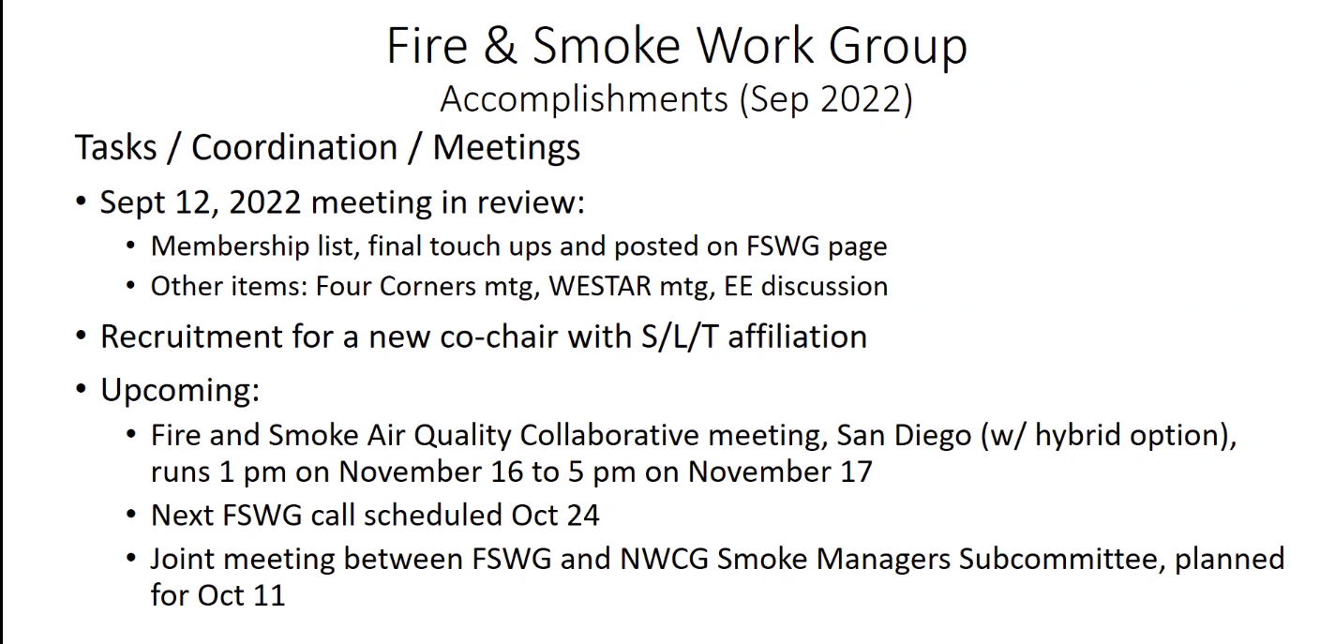

Paul Corrigan presented. Reminder to check out the resources from our Sept 12 meeting up on the WRAP website. This includes a number of smoke topics from the Four Corners Meeting. Check out the exceptional events recording, skip to about minute 11, that’s when the presentation begins.
Rhonda Payne shared that Mark Jones did an excellent job planning the Four Corners Meeting with a fantastic field trip to Chaco Canyon.
Question from Julie: the joint meeting with the FSWG and the Smoke Managers Committee, has there been a meeting invite sent out? Paul Corrigan will follow up.

  - OGWG
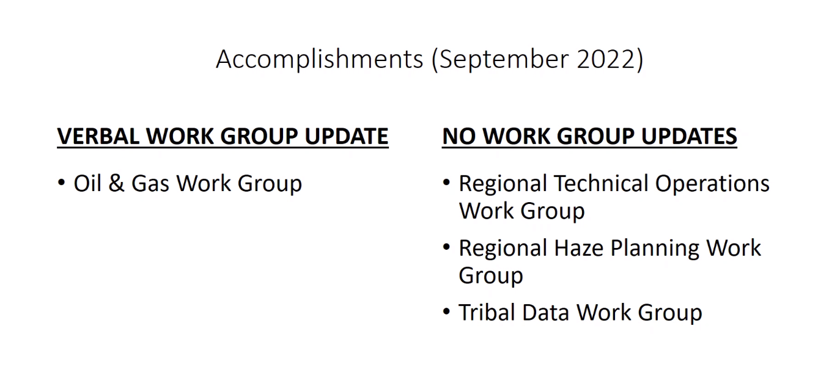

Amanda Brimmer Presented: Not much to update the group on this month, still working on the survey responses.
No questions

  - RTOWG – no updates this month
  - TDWG – no updates this month
  - RHPWG – no updates this month
No other questions for the other work groups

- TSC Administrative and Informational Items (15 minutes)
  - TSC Vacancy: Local (Darla)
    - Jon Klassen, San Joaquin Valley APCD, potential TSC Local Member (Not on call)
  - WG Co-Chair Nomination (Rhonda Payne)
    - Matt Pace, Arizona DEQ nominated to be 3rd FSWG Co-Chair
TSC approved Matt as 3rd FSWG Co-Chair. Recommendation will be taken to the WRAP Board on Wednesday October 5, 2022.
  - Update on WRAP Charter Approval (Mary Uhl)
Work on the charter continues, Rhonda to provide update when complete.
  - Update on website(s) work (Mary)
Has been a much bigger lift than we thought it would be. Estimated beta version end of November, maybe going live by end of year. Other groups (e.g. NESCAUM) are experiencing similarly long process (~2 years) to update their websites.
No questions.
  - Meetings and Conferences (Julie)
    - WESTAR/WRAP Fall Business Meeting, Sept. 7-8, 2022, Missoula, MT (final agenda and recordings) (Mary)
Recordings will be made available hopefully by the end of the week. Summary of the meeting has been posted with links to the presentations. Waiting for the Residential Wood Heating presentation from EPA. Field trip to the Missoula Fire Lab was excellent. [On Friday, September 30, 2022 Mary Uhl emailed the following “the fall business meeting recordings and a summary of the meeting with links to presentations on the WESTAR website under downloads: http://www.westar.org/downloads.html.” ]
    - Northwest AIRQUEST, Oct. 13, 2022, virtual (in-person TBD) (Julie)
Fall meeting agenda will be shared when that comes out.
    - Community Modeling and Analysis System (CMAS) Conference, Oct. 17-19, 2022, Chapel Hill, NC
    - NASA HEALTH AND AIR QUALITY APPLIED SCIENCES TEAM (HAQAST), Oct. 20-21, 2022, Madison, WI (hybrid) (Mary)
Opportunity for travel expenses to be paid. Can attend remotely too.
No questions.
    - National Atmospheric Deposition Program (NADP) Fall Meeting, Nov. 14–18, 2022, Knoxville, TN (hybrid) (Mike Barna)
    - WESTAR/WRAP Western Visibility Initiative & Fire and Smoke Air Quality Collaborative meetings, Nov. 15-17, 2022, San Diego, CA (Jay Baker)
    - Working on draft agenda for the visibility conference. On the afternoon of the 15th there will be an in person only break out group.
    - Question from Julie: Will there be an opportunity to have a hybrid discussion group? Jay: they were talking about that – TBD.
    - Virtual attendees will miss the breakout group, however when we re-group the next day there will be a summary report.
    - FSWG has a draft agenda of the Fire & Smoke Meeting on their webpage.
    - On Nov 2-3, 2022 is the IMPROVE Steering Committee meeting in New Hampshire. If you’re interested in attending. Contact Scott.Copeland@colostate.edu. Remote Option will be available.
- Next Steps and Wrap up (5 minutes) – Darla
  - Review next steps and action items from call
    - Send any corrections to 8/24 call notes to Darla and Julie by COB Friday 9/30. Call notes will be posted to the WRAP Website as final the following week.
    - Approved WG member lists (with approved added names and email column deleted) and combined workbook of lists will be sent out and also posted to WRAP Website.
    - WGs please bring any member list updates to monthly coordination calls to get TSC approval.
    - Rhonda to send bio of Matt Pace to Darla for WRAP Board approval at 10/5 meeting.
  - Next call –
    - Wednesday, October 26, 2022, 11:30 PT / 12:30 MT
    - Note taker – John Vimont, NPS – Air Resources Div.
No additional items

Call Notetaking Schedule

Call Date | Time (PT) | Name | Agency | Representing | Geography
9/28/2022 | 11:30am – 1pm | Rupesh Patel | Pima Co. DEQ | Local | Arizona
10/26/2022 | 11:30am – 1pm | John Vimont | NPS – Air Resources Div. | Fed | National
11/30/2022 | 11:30am – 1pm | Jason Walker | NW Band, Shoshone Nation - Washakie Reservation | Tribal | Utah/Idaho
12/28/2022 | 11:30am – 1pm | Phil Swartzendruber | Puget Sound Clean Air Agency | Local | Washington
1/25/2023 | 11:30am – 1pm | Steve Miller | Idaho DEQ – Air Quality Bureau | State | Idaho
2/22/2023 | 11:30am – 1pm | Karl Seltzer | EPA OAQPS | Fed | National
3/29/2023 | 11:30am – 1pm | Danny Powers | Southern Ute Indian Tribe | Tribal | 4 Corners
4/26/2023 | 11:30am – 1pm | Tim Allen | FWS | Fed | National
5/29/2023 | 11:30am – 1pm | Kristen Martin | Oregon DEQ | State | Oregon
6/28/2023 | 11:30am – 1pm | Charis Cooper | BLM | Fed | National
7/26/2023 | 11:30am – 1pm | Paul Corrigan | USFS | Fed | Utah
8/30/2023 | 11:30am – 1pm | Gail Tonnesen | EPA – Region 8 | Fed | Intermountain
9/27/2023 | 11:30am – 1pm | Bob Kotchenruther | EPA Region 10 | Fed | Pacific NW

FSWG Fire and Smoke Work Group
OGWG Oil and Gas Work Group
RHPWG Regional Haze Planning Work Group
RTOWG Regional Technical Operations Work Group
TDWG Tribal Data Work Group
TSC Technical Steering Committee
WESTAR Western States Air Resource Council
WRAP Western Regional Air Partnership

